Installing a VPro Service Pack
- First things first, shut down VPro.
- Next you will need to backup VPro and the easiest way to do that is to zip it up.

- The service pack probably came zipped. Time to unzip and double-click the Access file to load the option form that has a grand total of two buttons. Either continue or chicken out.
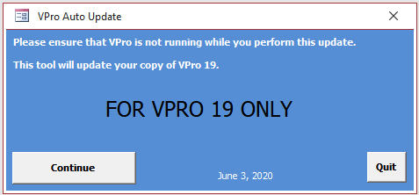
- Pressing continue will open the file browser. Locate your VPro19.accdb file and click the OK button.
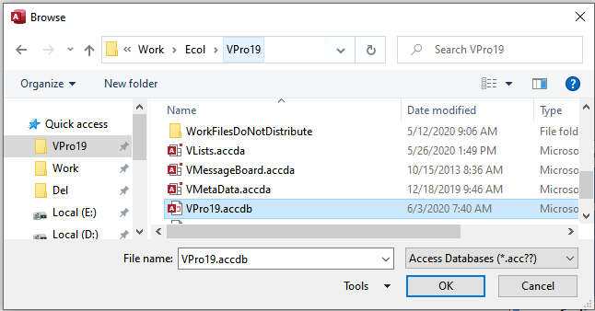

- If all goes according to plan you will be rewarded with one more message.
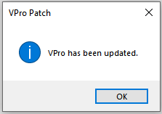
That is it. Click the Quit button and you are done. Reward yourself with your favorite beverage, a piece of chocolate or just relax with the knowledge and satisfaction that comes with a job well done.

